32) Aim: Design Turing Machine using simulator to perform string comparison where w={aba aba}.

Diagram:

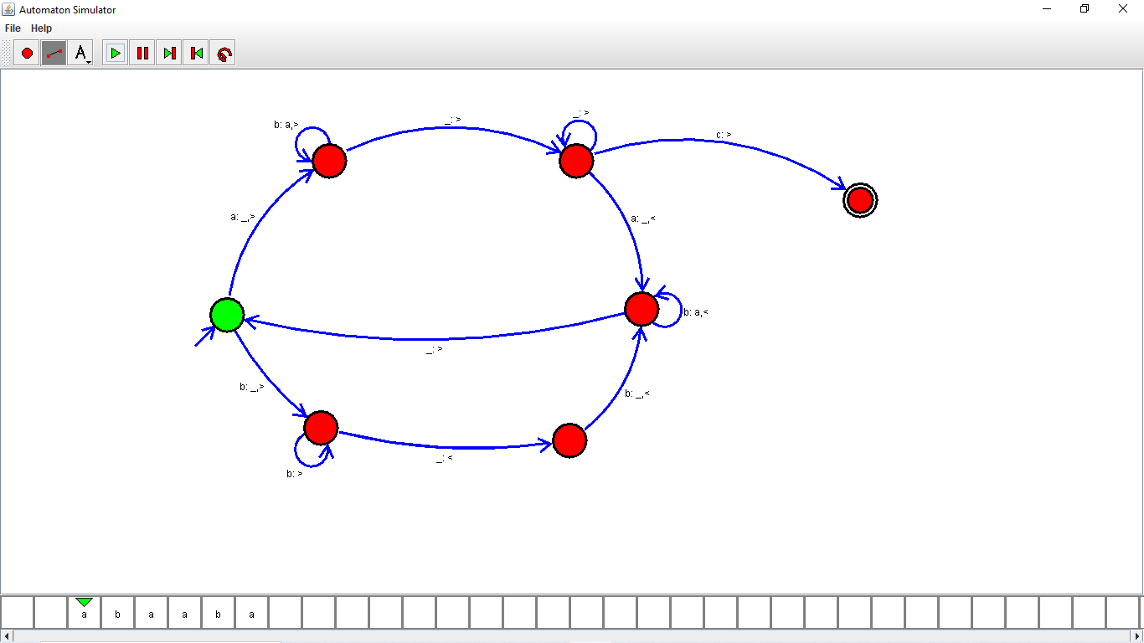

Result:

Successfully executed Design Turing Machine using simulator to perform string comparison where w={aba aba}.